**PRACTICUM REPORT**

Job sheet 11

Nasted Loop



RIDHO ANFA’AL

2341720222

CLASS 1I (INTERNATIONAL)

INFORMATICS ENGINEERING­­

INFORMATION TECHNOLOGY

STATE POLYTECHNIC OF MALANG

**Contents**

Experiment 1 3

Experiment 2 4

Experiment 3 6

Experiment 4 8

Experiment 5 10

Assignment 13

**Experiment 1**

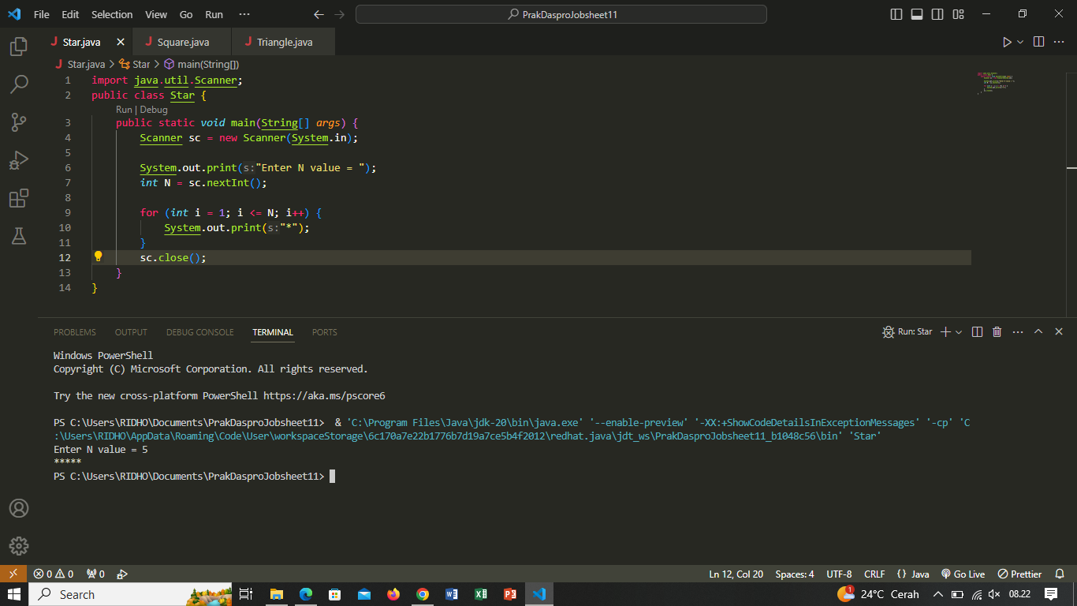

Pertanyaan

1. Jika pada perulangan for, inisialisasi i=1 diubah menjadi i=0, apa yang akibatnya? Mengapa bisa demikian?

Answer :

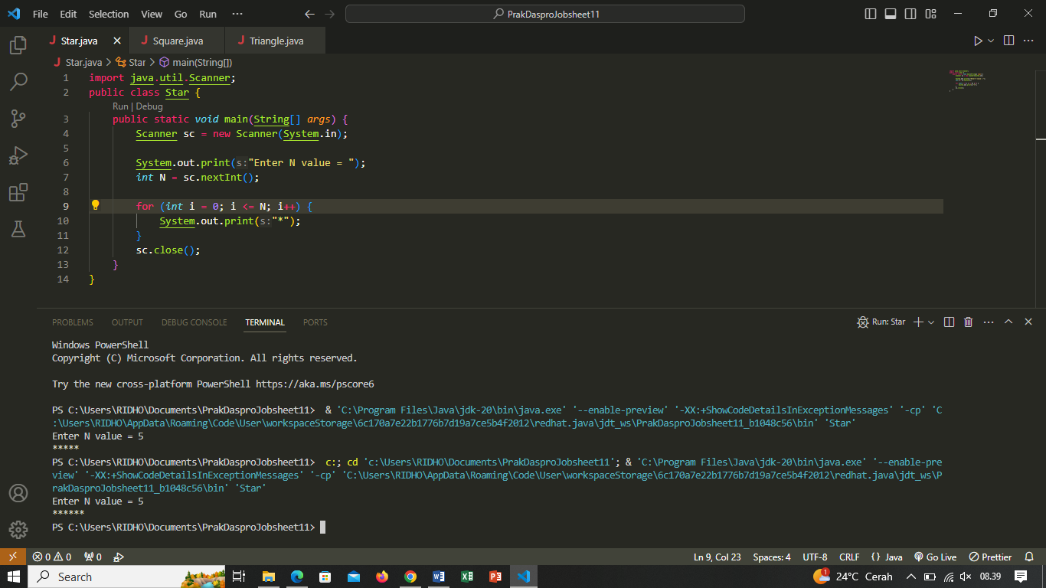

Modified program with initialization i = 0, then using i < N may cause the loop to run 6 times, resulting in 6 characters * if N is 5.

1. Jika pada perulangan for, kondisi i <= N diubah menjadi i > N, apa akibatnya? Mengapa bisa demikian?

Answer :

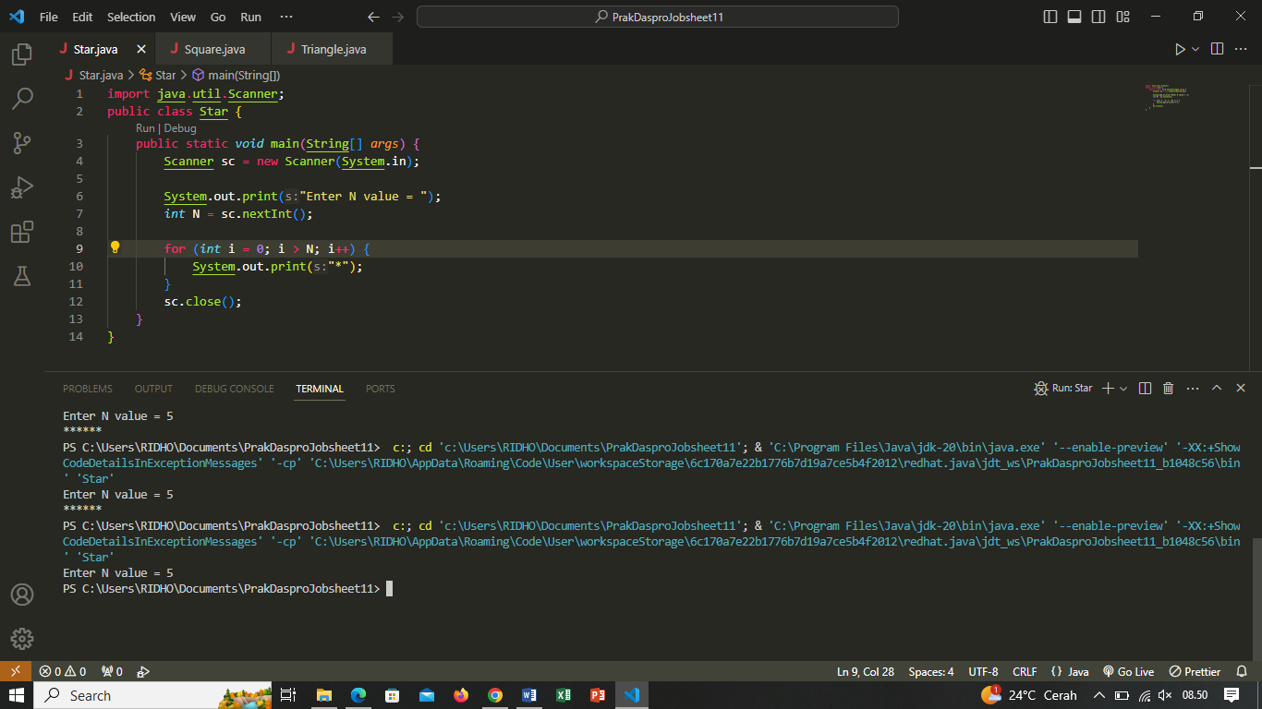

Loop will never happen because the condition i > N is always false from the beginning. Thus, the program output will not print any * characters.

1. Jika pada perulangan for, kondisi step i++ diubah menjadi i-- apa akibatnya? Mengapa bisa demikian?

Answer :

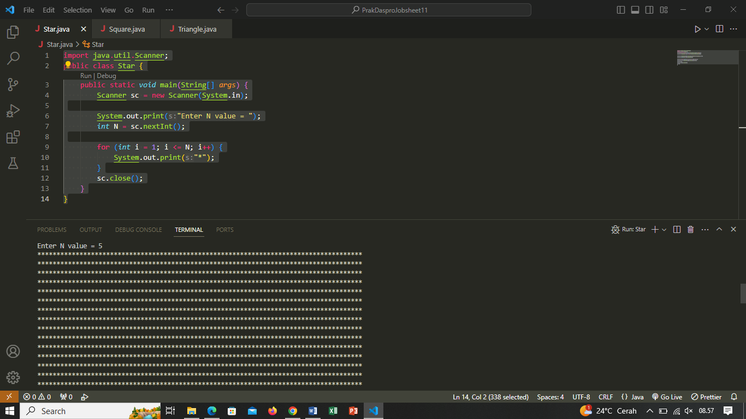

The loop will still print the character N times, but the value of i will keep decreasing with each iteration. This will cause the loop to become an infinite loop, as the value of i will never reach a termination condition (i <= N). The program will continue to print the character without stopping.

**Experiment 2**

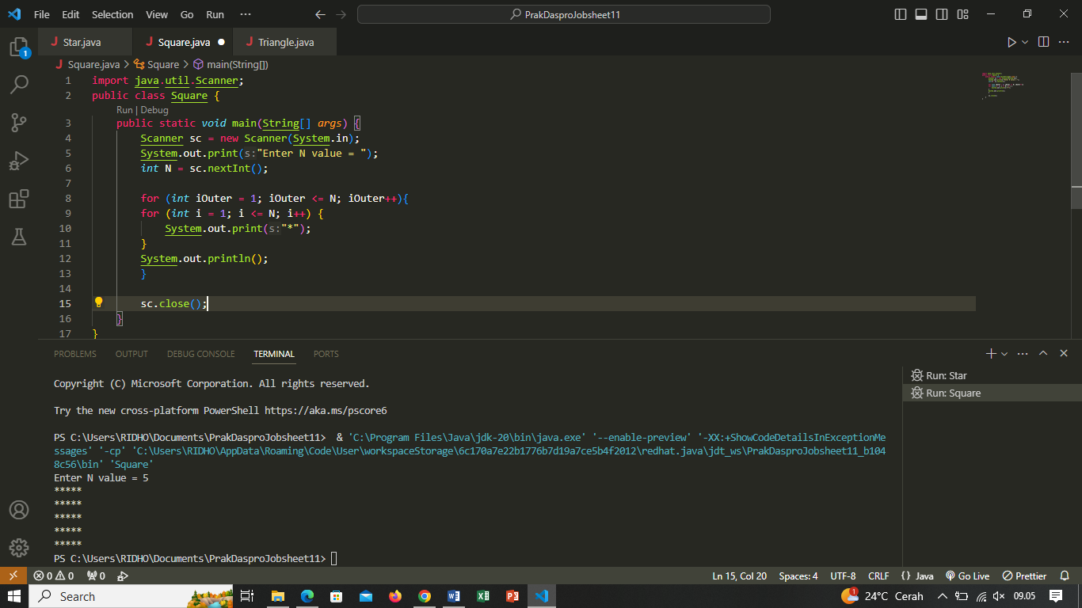

Pertanyaan

1. Perhatikan perulangan luar. Jika pada sintaks for, inisialisasi iOuter=1 diubah menjadi iOuter=0, apa yang akibatnya? Mengapa bisa demikian?

Answer :

Outer loop (iOuter) starts from 0 and ends when iOuter is less than N. This means the outer loop will run N times, and each time it will print N lines of * characters. The end result will still form a square with N lengths and widths.

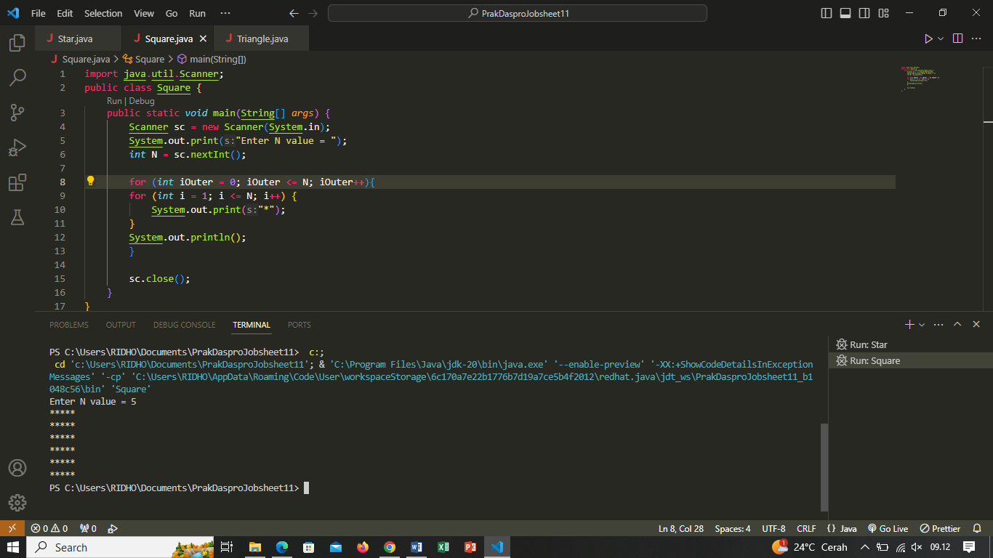

1. Kembalikan program semula dimana inisialisasi iOuter=1. Kemudian perhatikan perulangan dalam, Jika pada sintaks for, inisialisasi i=1 diubah menjadi i=0, apa yang akibatnya? Mengapa bisa demikian?

Answer : The loop in (i) starts from 0 and ends when i is less than N. This means each row of * characters will start from index 0 to N-1. The end result is still a square with N lengths and widths.

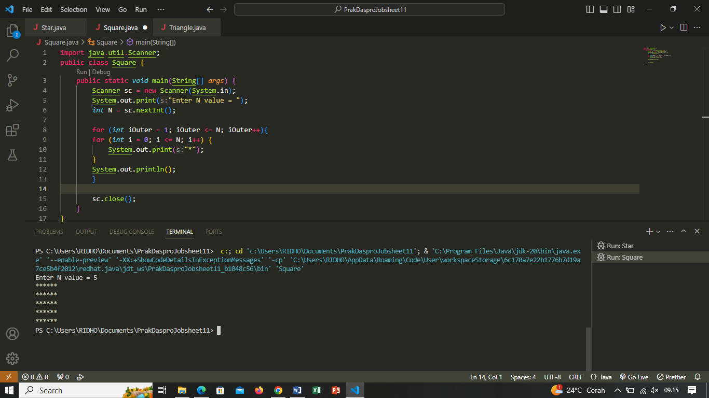

1. Jadi, apakah perbedaan kegunaan antara perulangan luar dengan perulangan yang berada didalamnya?

Answer : Outer loops and inner loops (nested loops) are basic concepts in programming that allow repetition within repetition. Each has different roles and uses:

Outer Loop:

- Controls the number of times the entire inner looping block will be executed.

- Usually used to set the number of times a certain pattern or action will be repeated.

Inner Loop:

- Controls the number of times a block of inner statements will be executed.

- Used to manage the details of an action repeated by the outer loop.

1. Mengapa perlu ditambahkan sintaks System.out.println(); di bawah perulangan dalam? Apa akibatnya jika sintaks tersebut dihilangkan?

Answer : The syntax System.out.println(); below the inner loop (deeper for) in the given example program is used to print a new line after one iteration of the inner loop is completed. This has the effect that each line of * characters in the output is printed in a different line, forming a square pattern. If the syntax System.out.println(); is omitted, then all lines of characters will be printed in a single line without line separation. That is, the characters on each iteration of the inner loop will be displayed on the same line. This will result in output such as one long line of characters*, instead of the desired square pattern.

1. Silakan commit dan push ke repository Anda

Answer :

**Experiment 3**

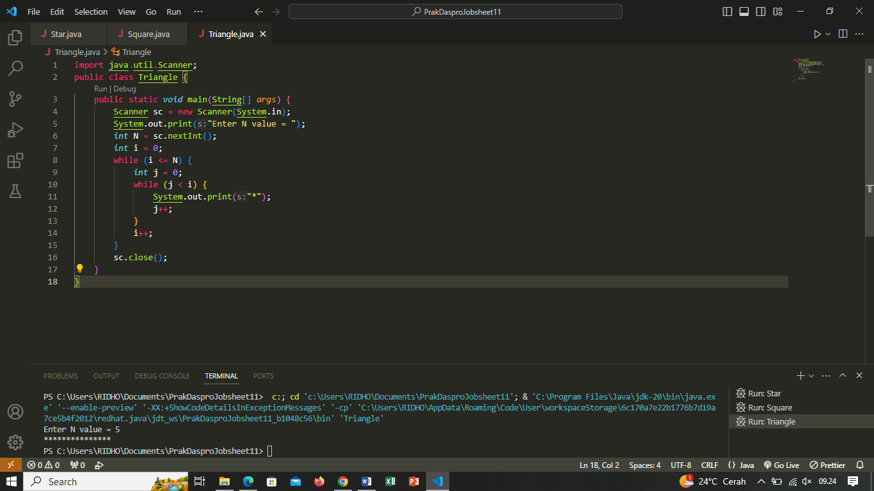

Pertanyaan

1. Perhatikan, apakah output yang dihasilkan dengan nilai N = 5 sesuai dengan tampilan berikut?

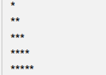

1. Jika tidak sesuai, bagian mana saja yang harus diperbaiki/ditambahkan? Jelaskan setiap bagian yang perlu diperbaiki/ditambahkan.

Answer : - int i = 0; Initialize variable i as row index, starting from 0.

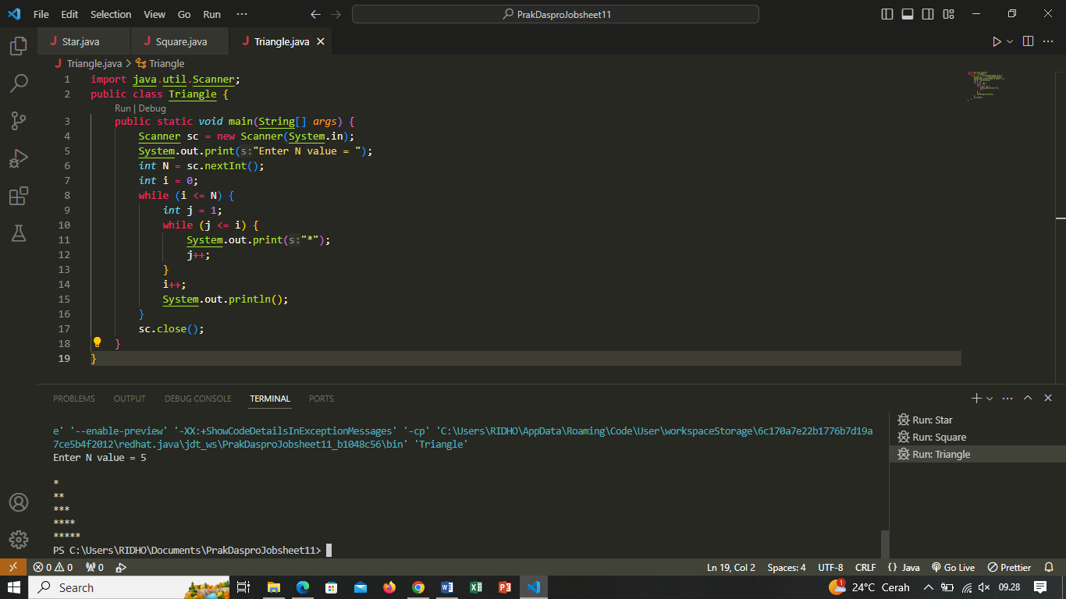

- while (i <= N) A loop that will run as long as the value of i is less than or equal to N.

- int j = 1; Initialize variable j as column index, starting from 1.

- while (j <= i) An inner loop that will print the character * as long as the value of j is less than or equal to i.

- System.out.print("*"); Prints the * character.

- j++; Increment the value of j.

- i++; Increment the value of i after one line of * has been printed.

- System.out.println(); Print a new line after one * line has been printed.

**Experiment 4**

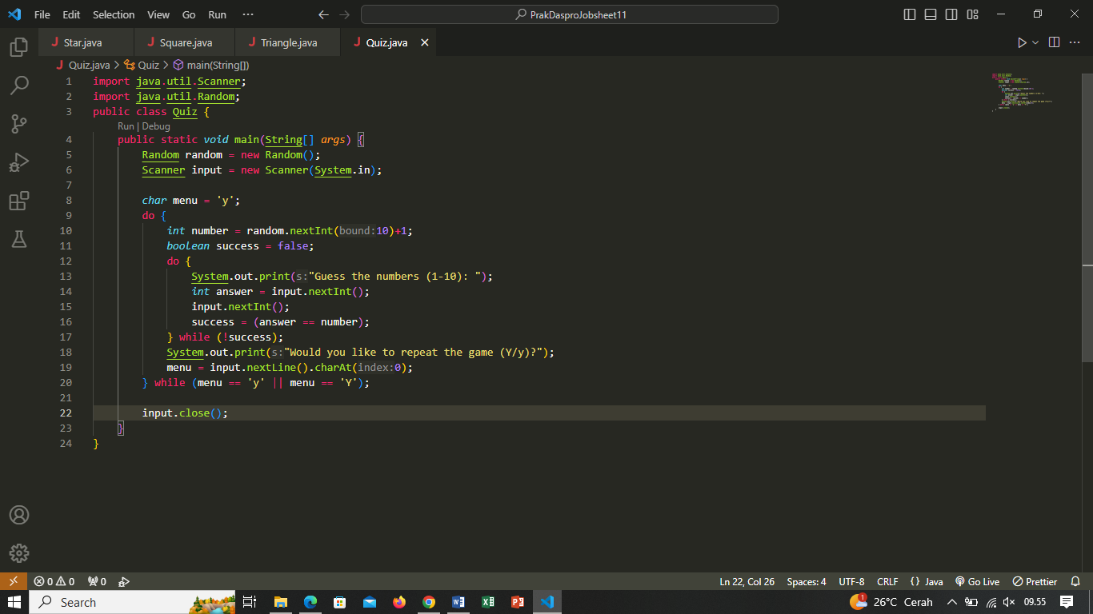

Pertanyaan

1. Jelaskan alur program di atas!

Answer :

* Import Library:

- import java.util.Scanner; Imports the Scanner class to read input from the user.

- import java.util.Random; Imports the Random class to generate random numbers.

* Variable Declaration:

- Random random = new Random(); Creates a Random object to generate random numbers.

- Scanner input = new Scanner(System.in); Creates a Scanner object to read input from the user.

- char menu = 'y'; Declares a menu variable with an initial value of 'y'. This variable is used to determine whether the user wants to repeat the game or not.

* Main Loop (do while):

- do while (menu == 'y' || menu == 'Y'); This loop will continue to run as long as the menu value is equal to 'y' or 'Y'. It controls whether the user wants to repeat the game or not.

* Guess the Number loop (do while):

- int number = random.nextInt(10) + 1; Generates a random number between 1 to 10 and stores it in the variable number.

- boolean success = false; Declares the success variable as false. This variable is used to determine whether the user has successfully guessed the number correctly.

- do while (!success); This loop will continue to run as long as the success value is false, meaning the user has not successfully guessed the number correctly.

* Guess the Numbers:

- System.out.print("Guess the numbers (1-10): "); Display a message for the user to guess the numbers.

- int answer = input.nextInt(); Reads the number guess from the user.

- input.nextInt(); Reads the newline character after the number guess.

- success = (answer == number); Checks if the user's guess is the same as the randomly generated number.

* Game Repetition:

- System.out.print("Would you like to repeat the game (Y/y)?"); Asks if the user wants to repeat the game.

- menu = input.nextLine().charAt(0); Reads the character input from the user to determine if they want to repeat the game.

- If the menu value is 'y' or 'Y', the program will return to the beginning of the main loop.

1. Apa yang harus dilakukan untuk tidak melanjutkan (tidak mengulangi) permainan tersebut?
2. Modifikasi program di atas, sehingga bisa menampilkan informasi mengenai : input nilai tebakan yang dimasukan oleh user apakah lebih kecil atau lebih besar dari jawaban/number yang di random!

Answer No. 2 & 3 :

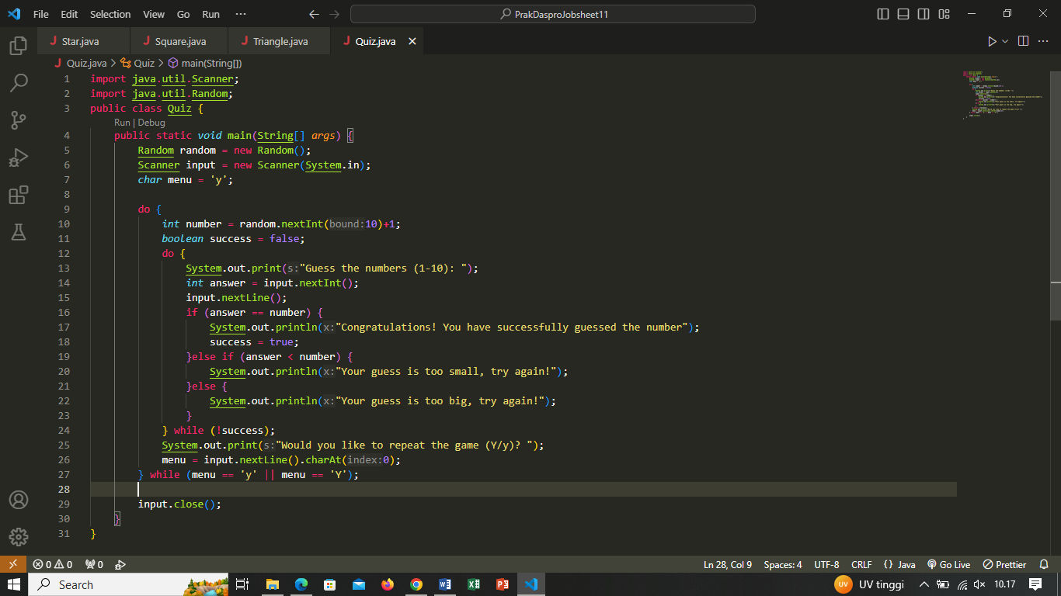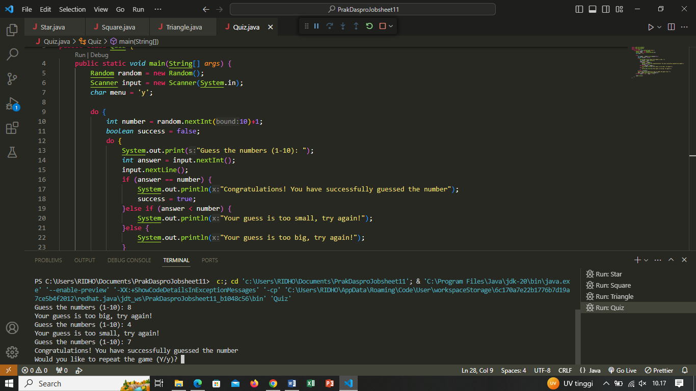

1. Silakan commit dan push ke repository Anda.

Answer :

**Experiment 5**

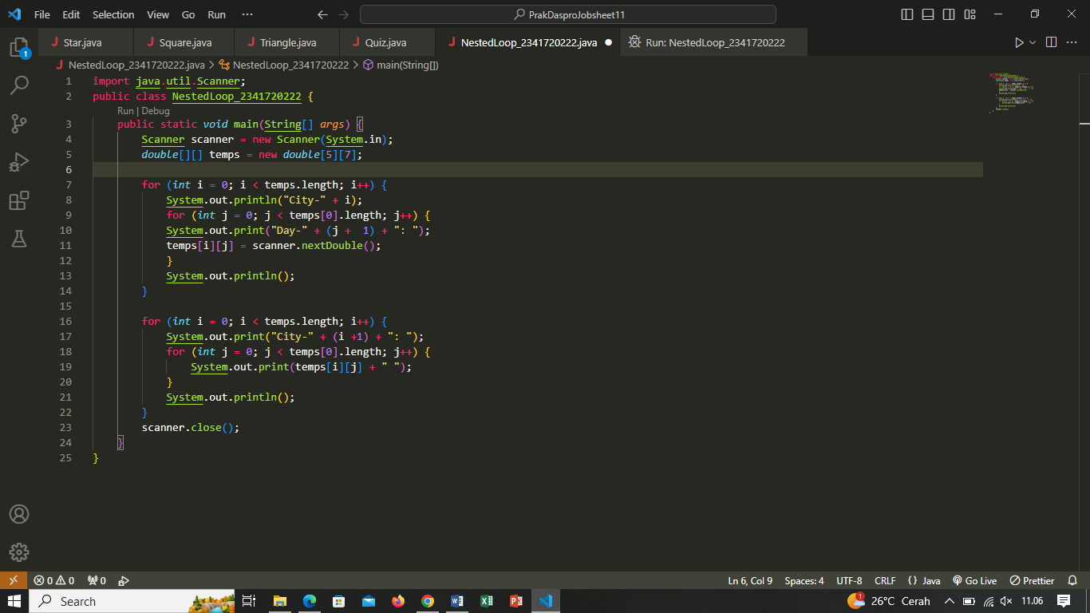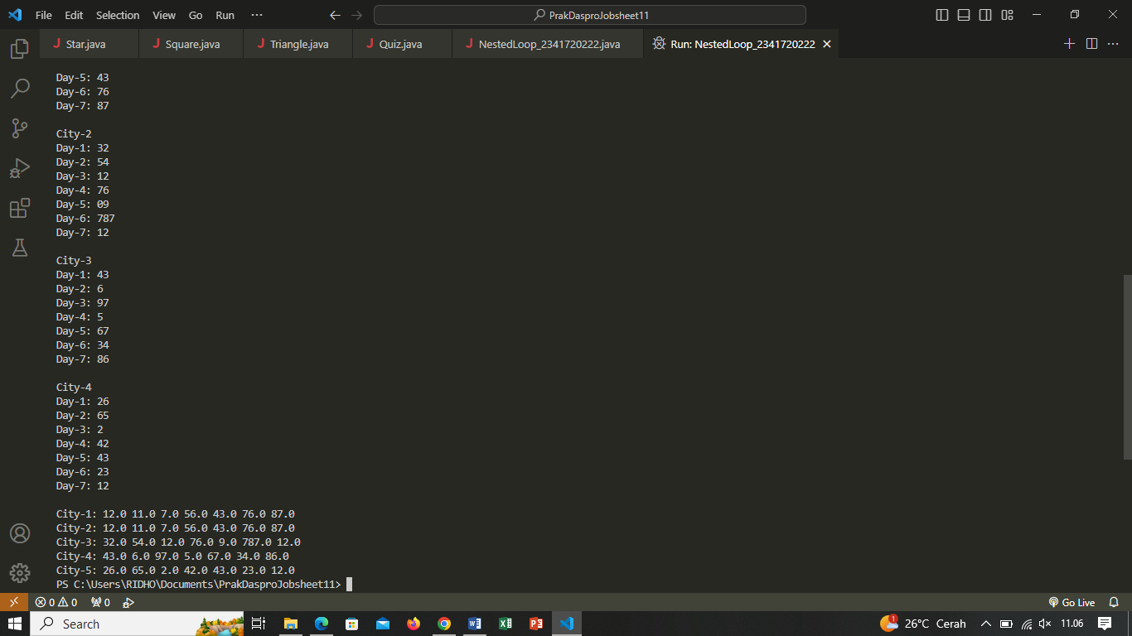

Pertanyaan

1. Jelaskan alur program di atas!

Answer :

Deklarasi Variabel dan Matriks:

* Scanner scanner = new Scanner(System.in);: Membuat objek Scanner untuk membaca input dari pengguna.
* double[][] temps = new double[5][7];: Mendeklarasikan matriks 2D temps dengan 5 baris (kota) dan 7 kolom (hari).

Input Suhu untuk Setiap Kota dan Hari:

* Pertama, program menggunakan perulangan for luar untuk iterasi melalui setiap kota (baris).
* Di dalam perulangan luar, terdapat perulangan for dalam untuk mengiterasi melalui setiap hari (kolom).
* Pada setiap iterasi, program mencetak prompt "City-i" diikuti oleh prompt "Day-j" dan membaca input suhu dari pengguna untuk kota i dan hari j, kemudian menyimpannya dalam matriks temps.

Menampilkan Data Suhu:

* Setelah selesai mengumpulkan data suhu, program menggunakan perulangan for luar untuk iterasi melalui setiap kota.
* Di dalam perulangan luar, terdapat perulangan for dalam untuk mengiterasi melalui setiap hari.
* Pada setiap iterasi, program mencetak data suhu dari matriks temps untuk setiap kota dan hari.
* Hasilnya adalah tampilan data suhu untuk setiap kota, diurutkan berdasarkan hari.

1. Silakan modifikasi program di atas pada bagian untuk menampilkan array menggunakan foreach! Answer : 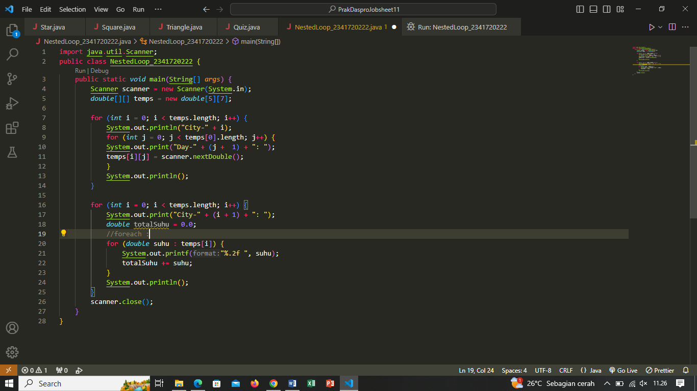

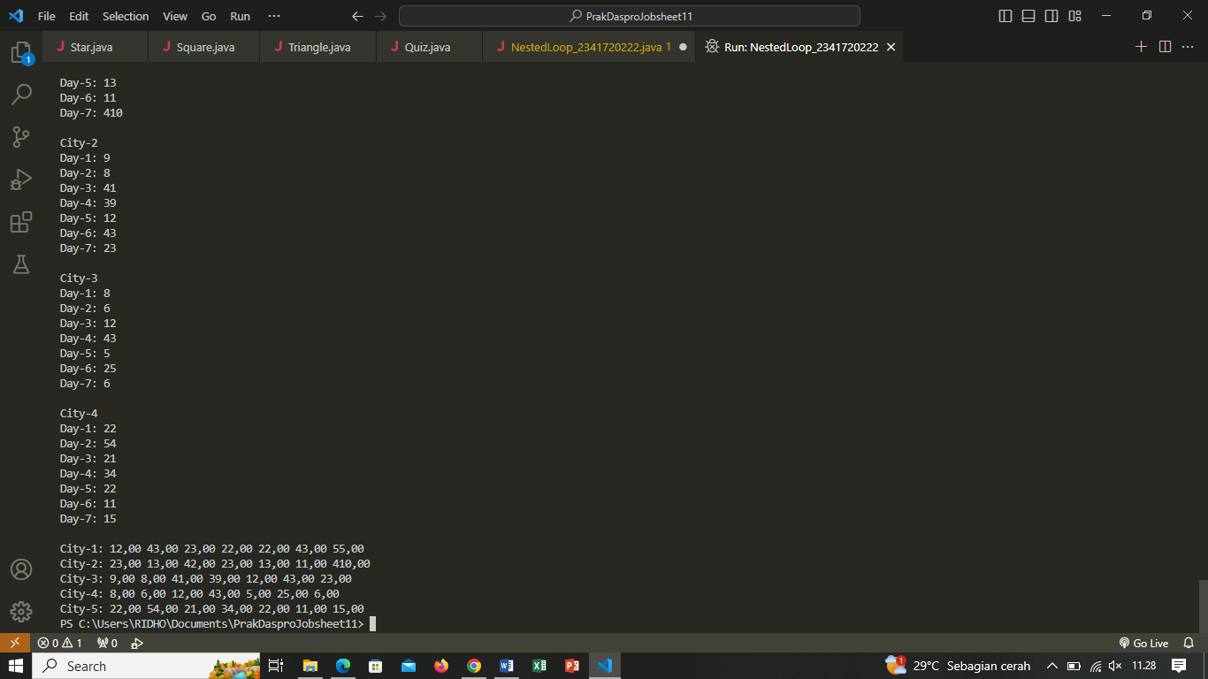

1. Modifikasi program di atas sehingga bisa menampilkan nilai rata-rata masing-masing kota! Answer :

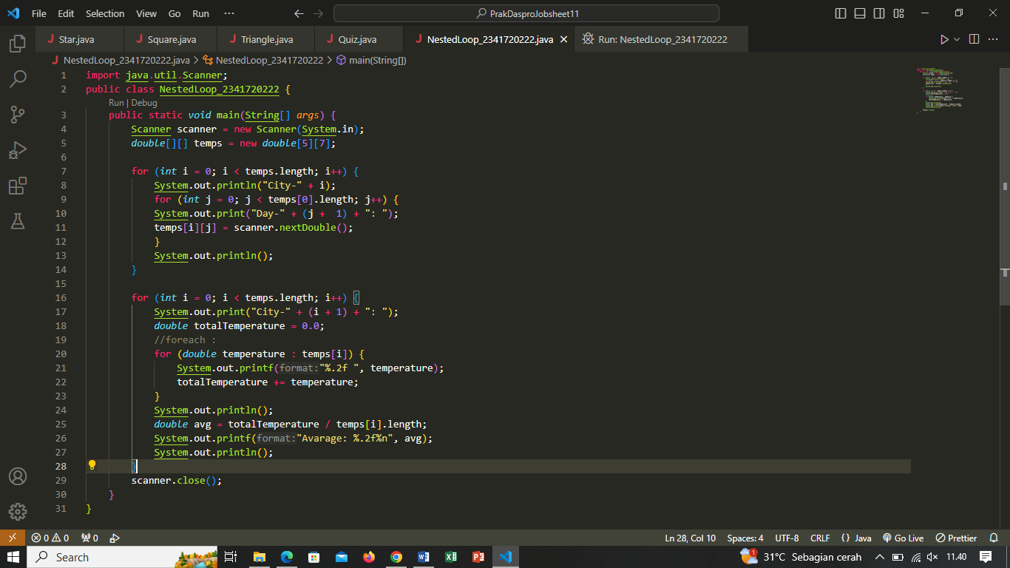

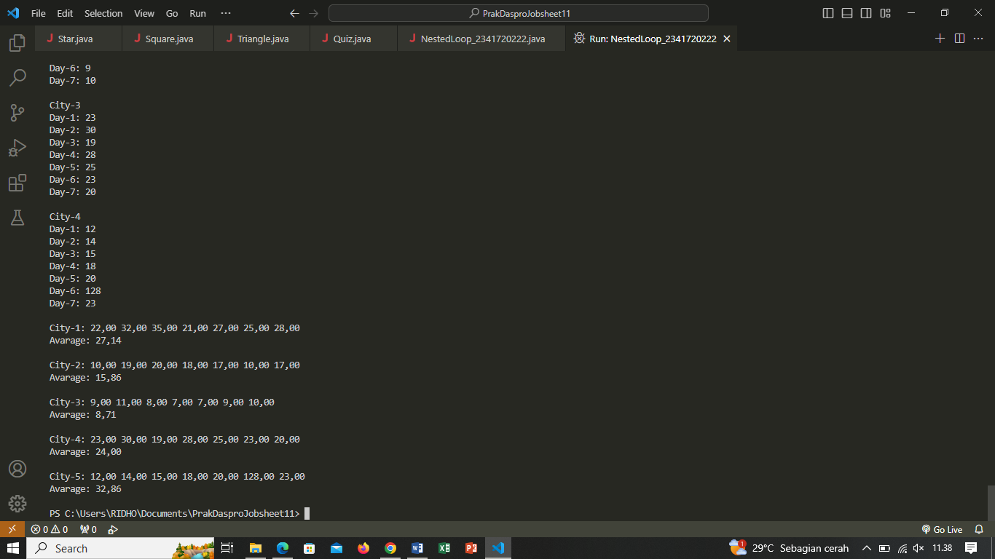

1. Silakan commit dan push ke repository Anda. Answer :

Tugas individu dan kelompok

1. Buatlah program untuk mencetak tampilan segitiga angka seperti di bawah ini berdasarkan input N (nilai N minimal 3). Contoh N = 5

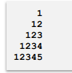

Answer : 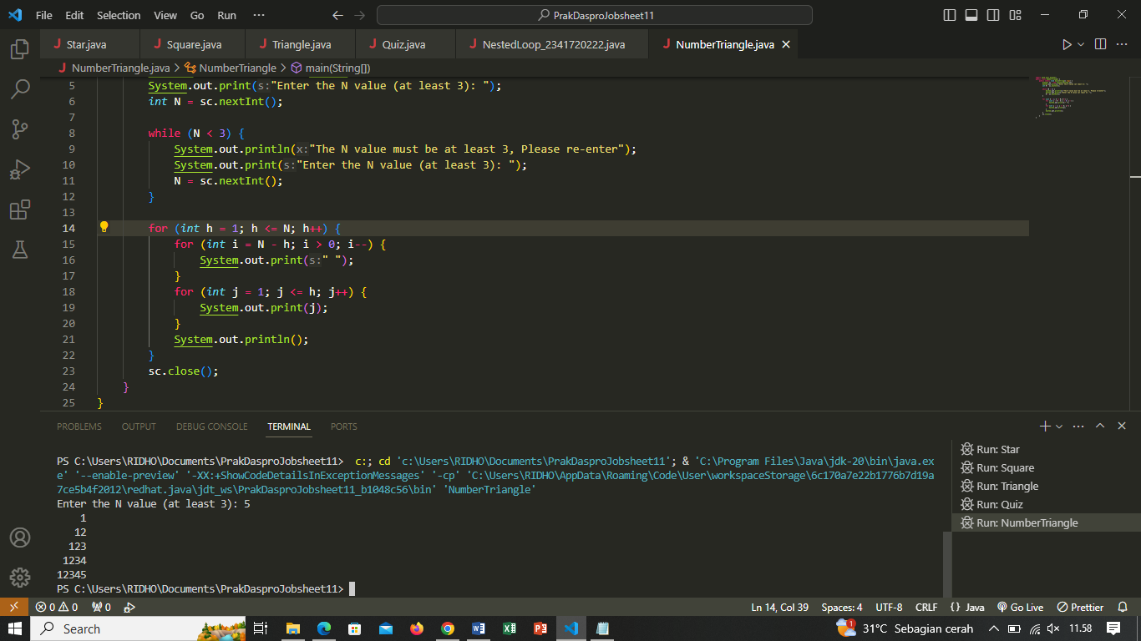

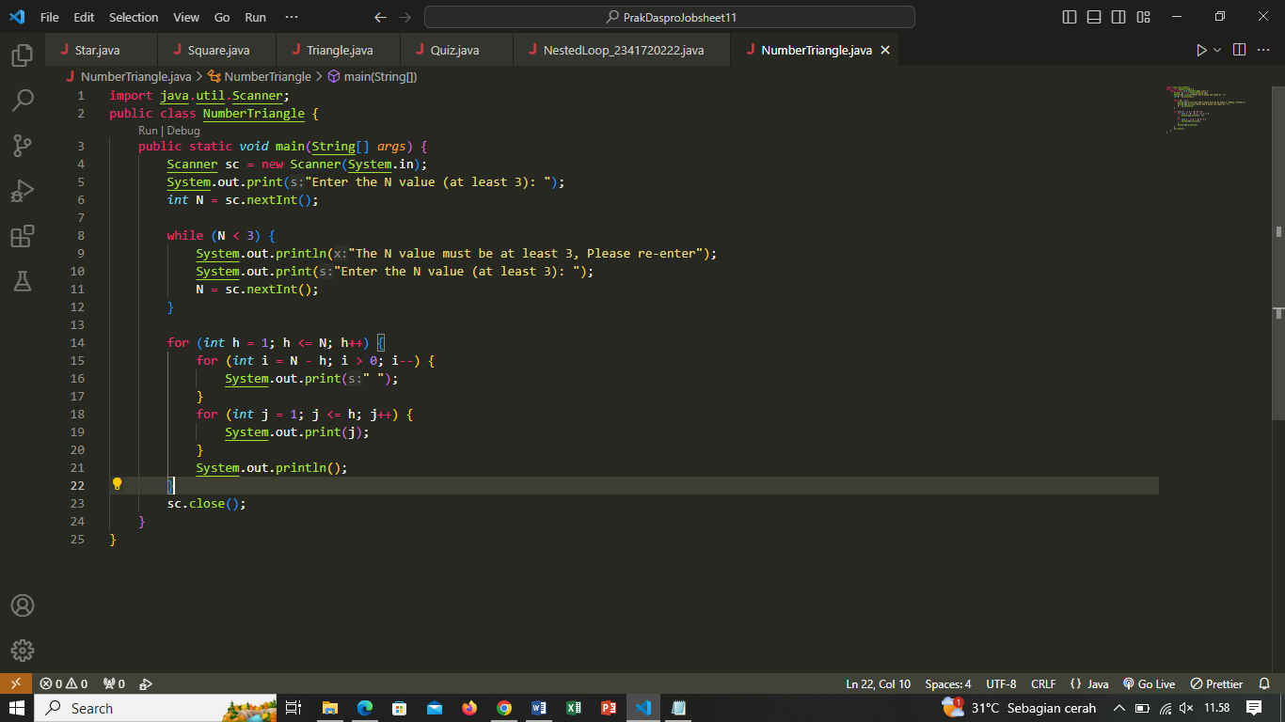

1. Buatlah program untuk mencetak tampilan segitiga bintang seperti di bawah ini berdasarkan input N (nilai N minimal 5). Contoh N = 7

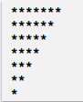

Answer : 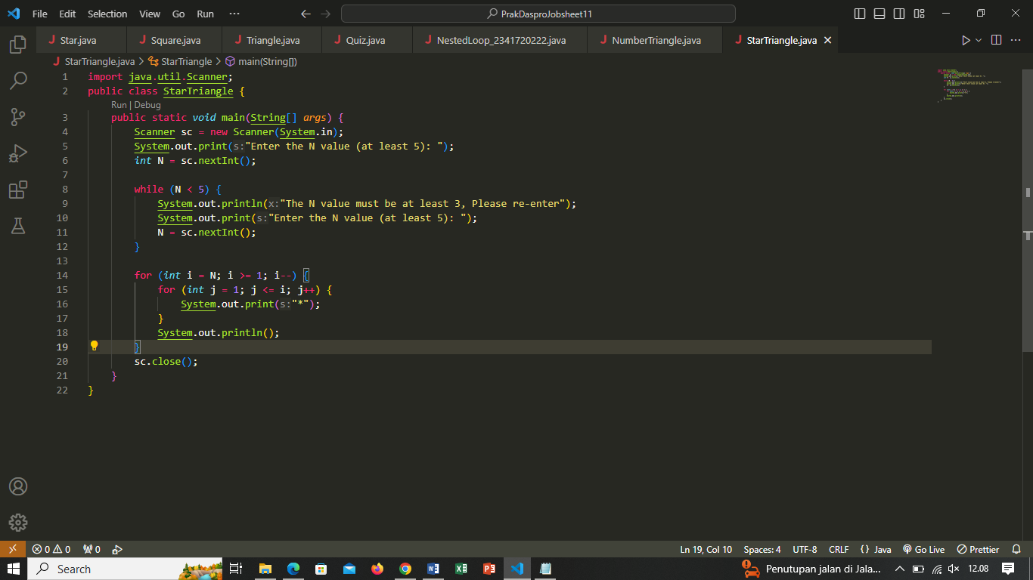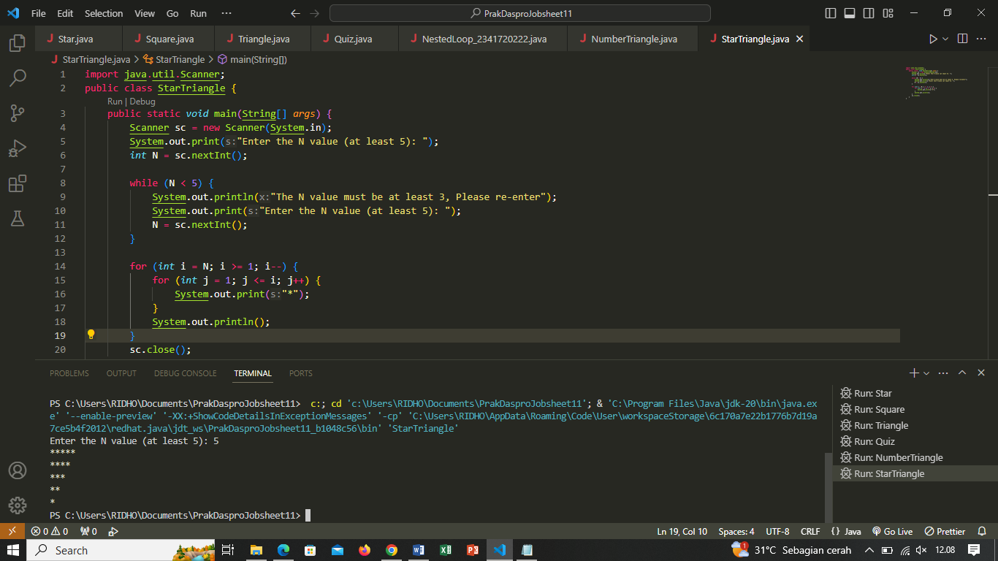

1. Buatlah program untuk mencetak tampilan persegi angka seperti di bawah ini berdasarkan input N (nilai N minimal 3). Contoh N = 3, dan N = 5 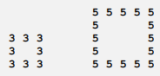

Answer : 